**Unsharp mask and how come ‘unsharp’ sharpens an image :**

1. **Read our image and convert it into floating point value :**

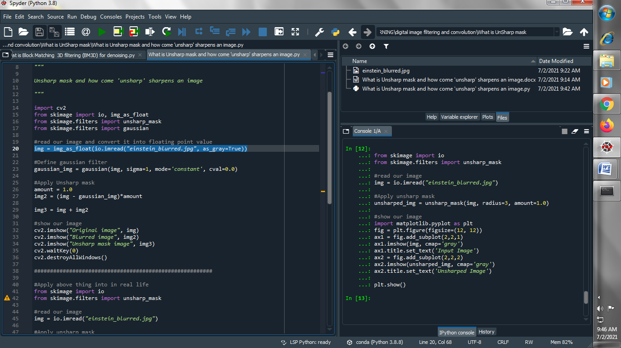

1. **Define Gaussian filter for blurr the image :**

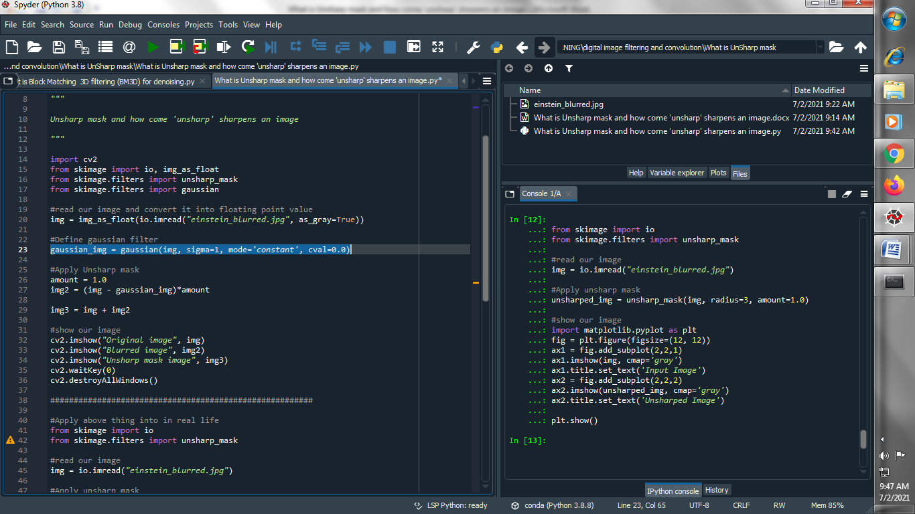

1. **Apply unsharp mask :**

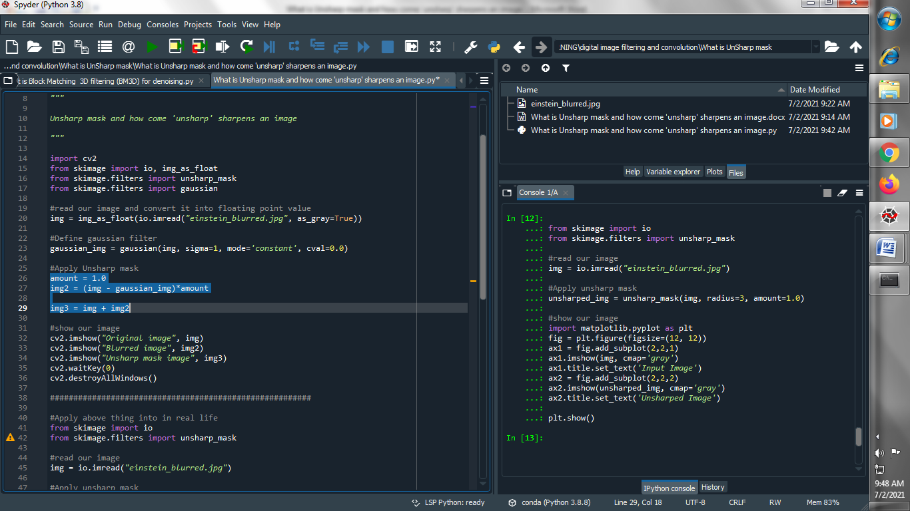

1. **Show our image :**

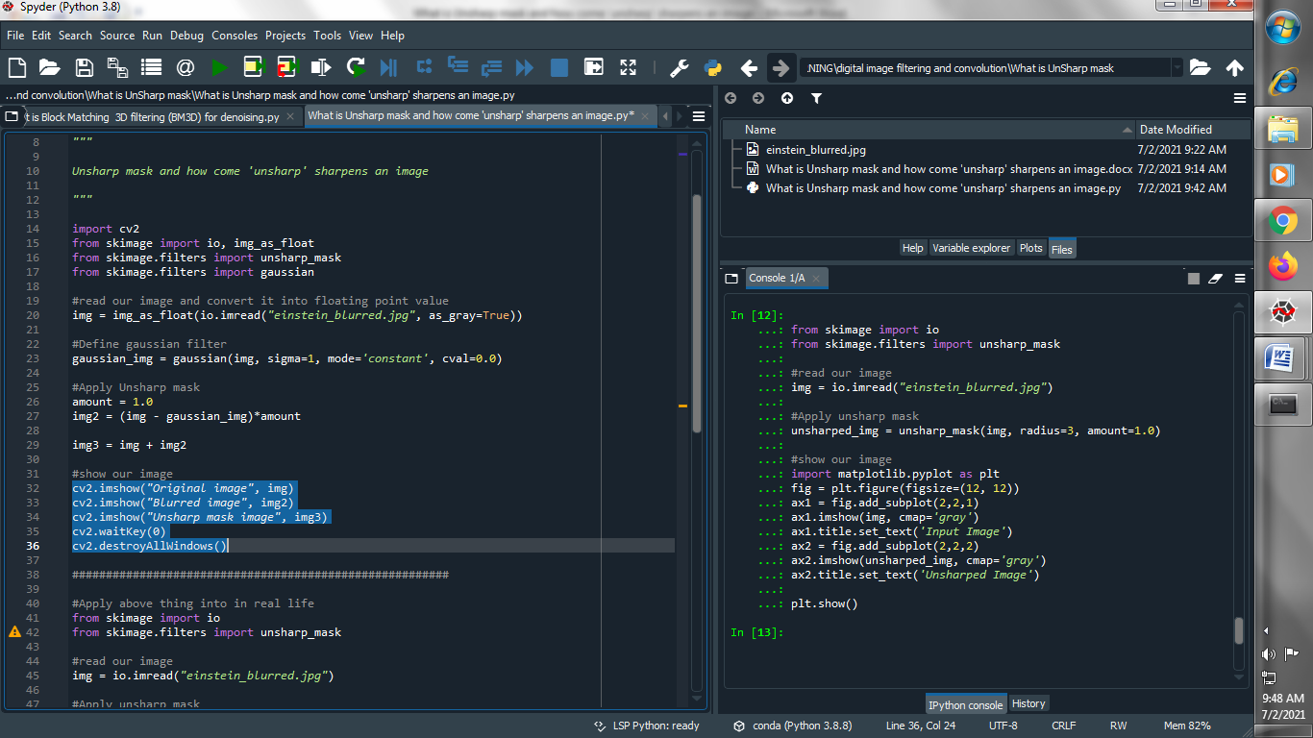

**Output :**

**Original image :**

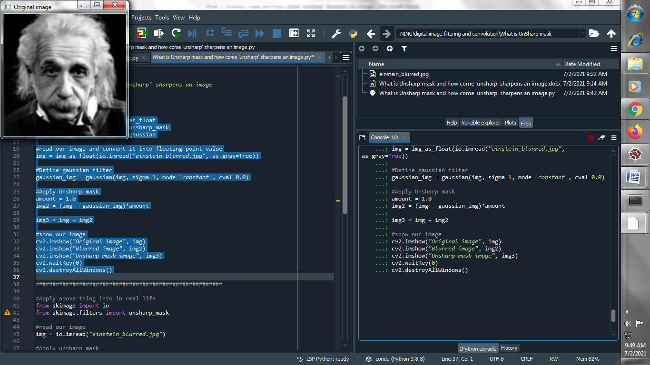

**Blurred image :**

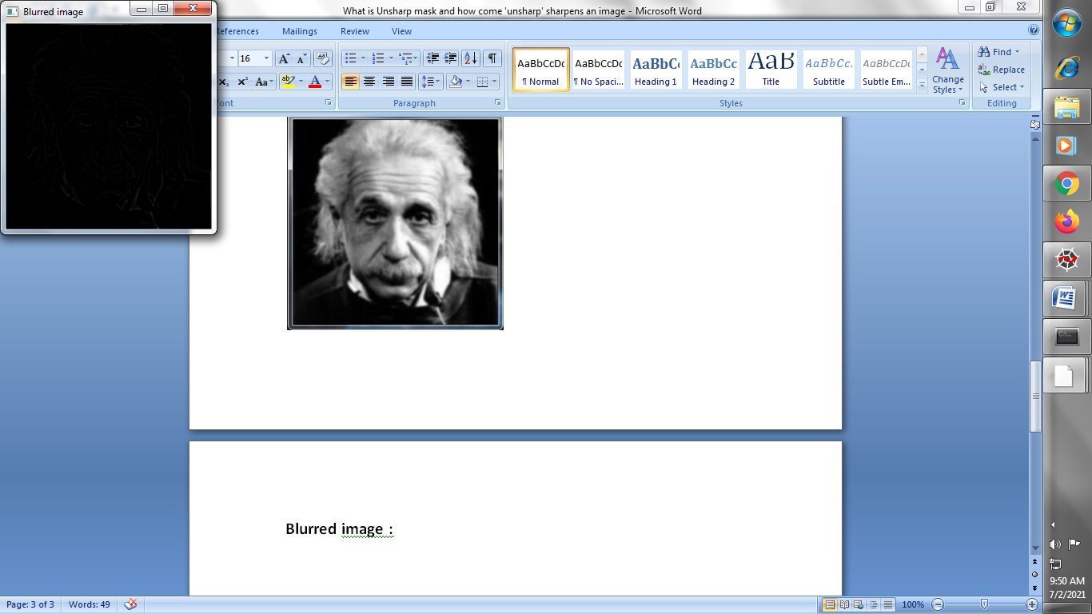

**Unsharp mask image :**

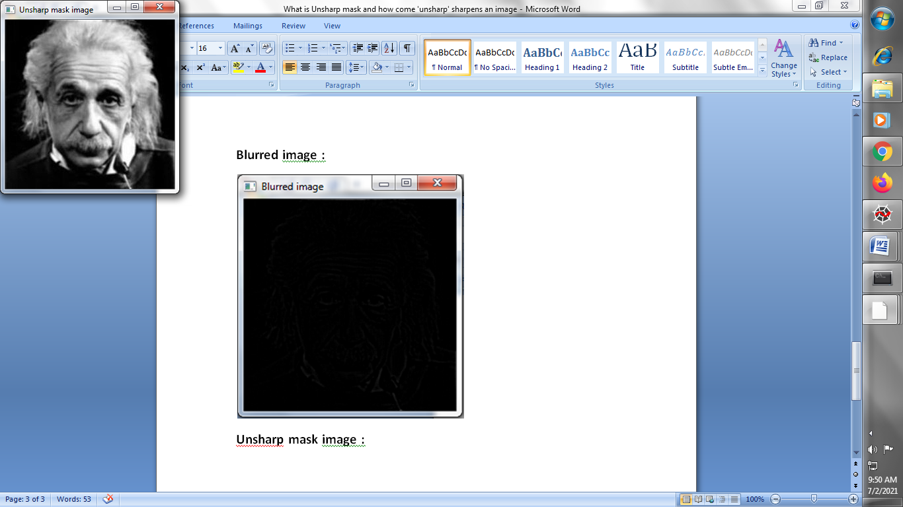

**→ Apply above all the things in our real life :**

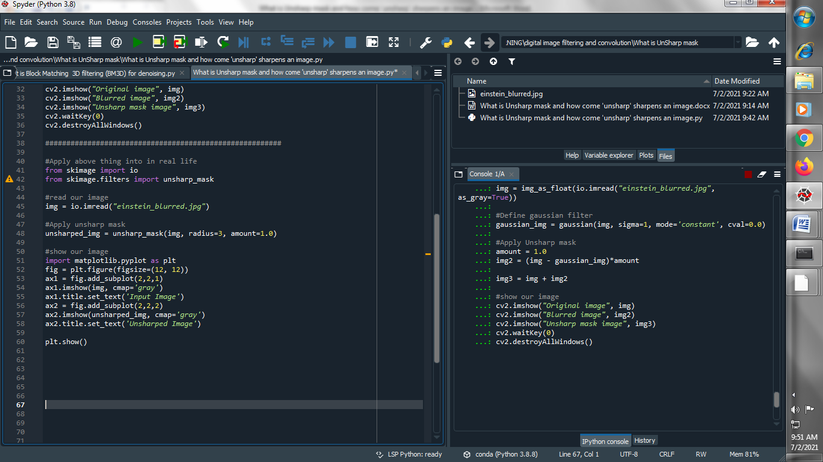

**Same output as above get**